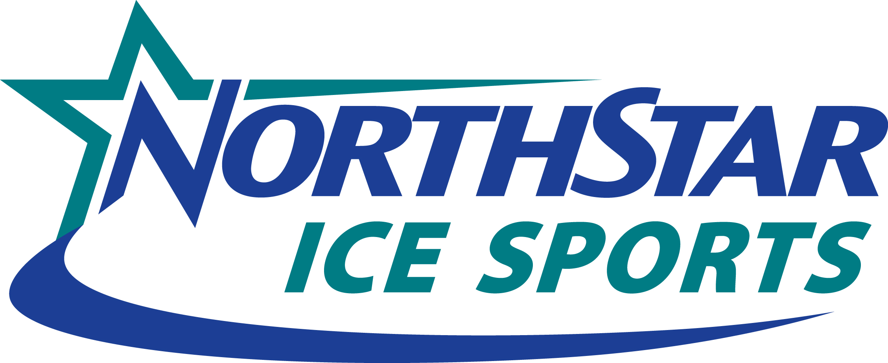 www.northstaricesports.com
15 Bridle Lane
Westborough, MA 01581
508-366-1562

NORTH STAR YOUTH HOCKEY LEAGUE 2017-2018 TEAM CONFLICT FORM

DEADLINES FOR SUBMITTING CONFLICT:

PLEASE CIRCLE ROUND:

Round 1 JULY 15 Round 2 OCTOBER 16 Round 3 NOVEMBER 27 Playoffs FEBRUARY 1
(9/09 – 10/27) (10/28– 12/08) (12/09 – 3/18 (tentative) (3/19–end of season)

Today’s Date _______________________________________________________________________________

Organization Name _________________________________________________________________________

Name of Contact ____________________________________________________________________________

Contact E-mail (req.) ________________________________________ Phone___________________________

TEAM (include color, #, or letter) _______________________________________________________________

DIVISION__________________________________________________________________________________

CONFLICT Begins: DATE: ________________________TIME: ______________AM/PM________

CONFLICT Ends: DATE: ________________________TIME: ______________AM/PM________

REASON FOR CONFLICT______________________________________________________________________________________________________________________________________________________________________________________________________________________________________________________________________

COMMENTS__________________________________________________________________________________________________________________________________________________________________________

EMAIL FORM TO: JoAnne Bliss / jbliss@northstaricesports.com (NEW EMAIL ADDRESS)

Note: Please call 508-366-1562 x236 if conflict does not appear on the website within 3-5 days.

northstaricesports.com youth league conflict request form summary of reported conflicts

